♥
The Campfire Book
SECOND EDITION

Preserve What Matters.

♥
The Campfire Book
SECOND EDITION
Campfire Technologies LLC
Cheyenne, Wyoming

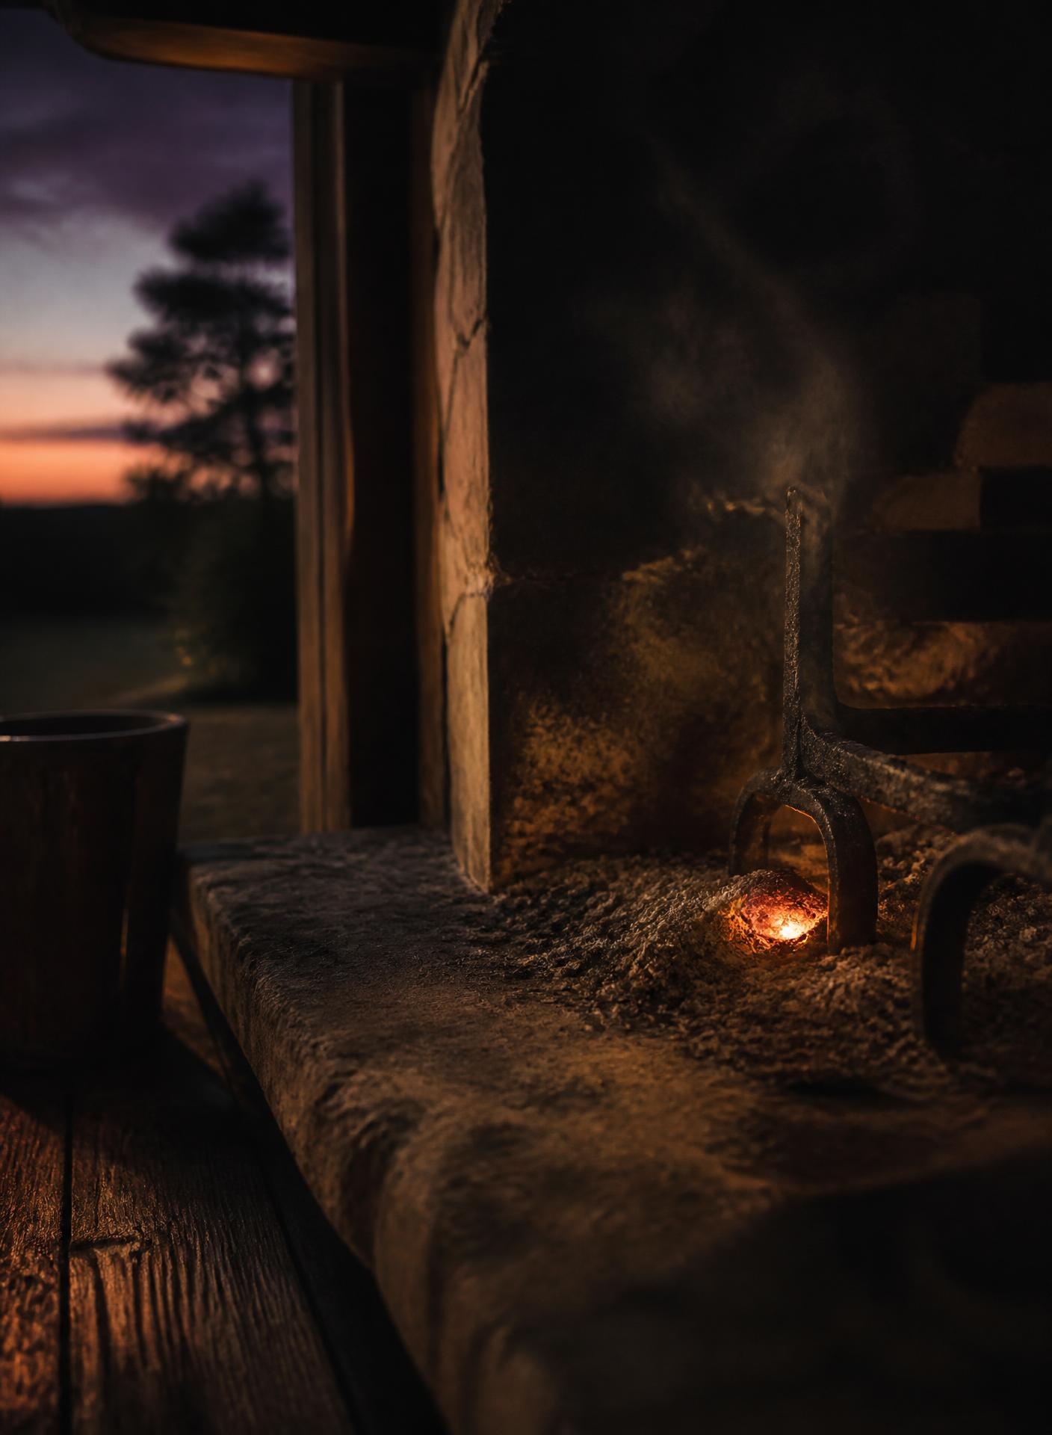

One
The Beginning
“Every story begins as a moment someone almost forgot.”
— Campy

I had started using AI as a personal journal.
Not for work. Not for anything clever. Every day I talked with it about my life — what happened, who I saw, what was weighing on me, what made me laugh. It was the easiest way I had ever found to say the day out loud.
Every week I saved those conversations. I saved them because I imagined that one day my children — and someday my grandchildren — might enjoy reading them. Not the polished version of me. The real one.
In the summer we took the camper to Glendo, Wyoming.
It was a good trip. On the way home I pulled into the dump station to empty the black and gray tanks before heading back, because that is what you do. Nobody takes a picture of that part of camping.
Standing there, doing the thing every camper eventually has to do, I laughed and texted:
“Story of my life… cleaning up people’s shit 😂😂”
And then, still standing there, a different thought arrived.

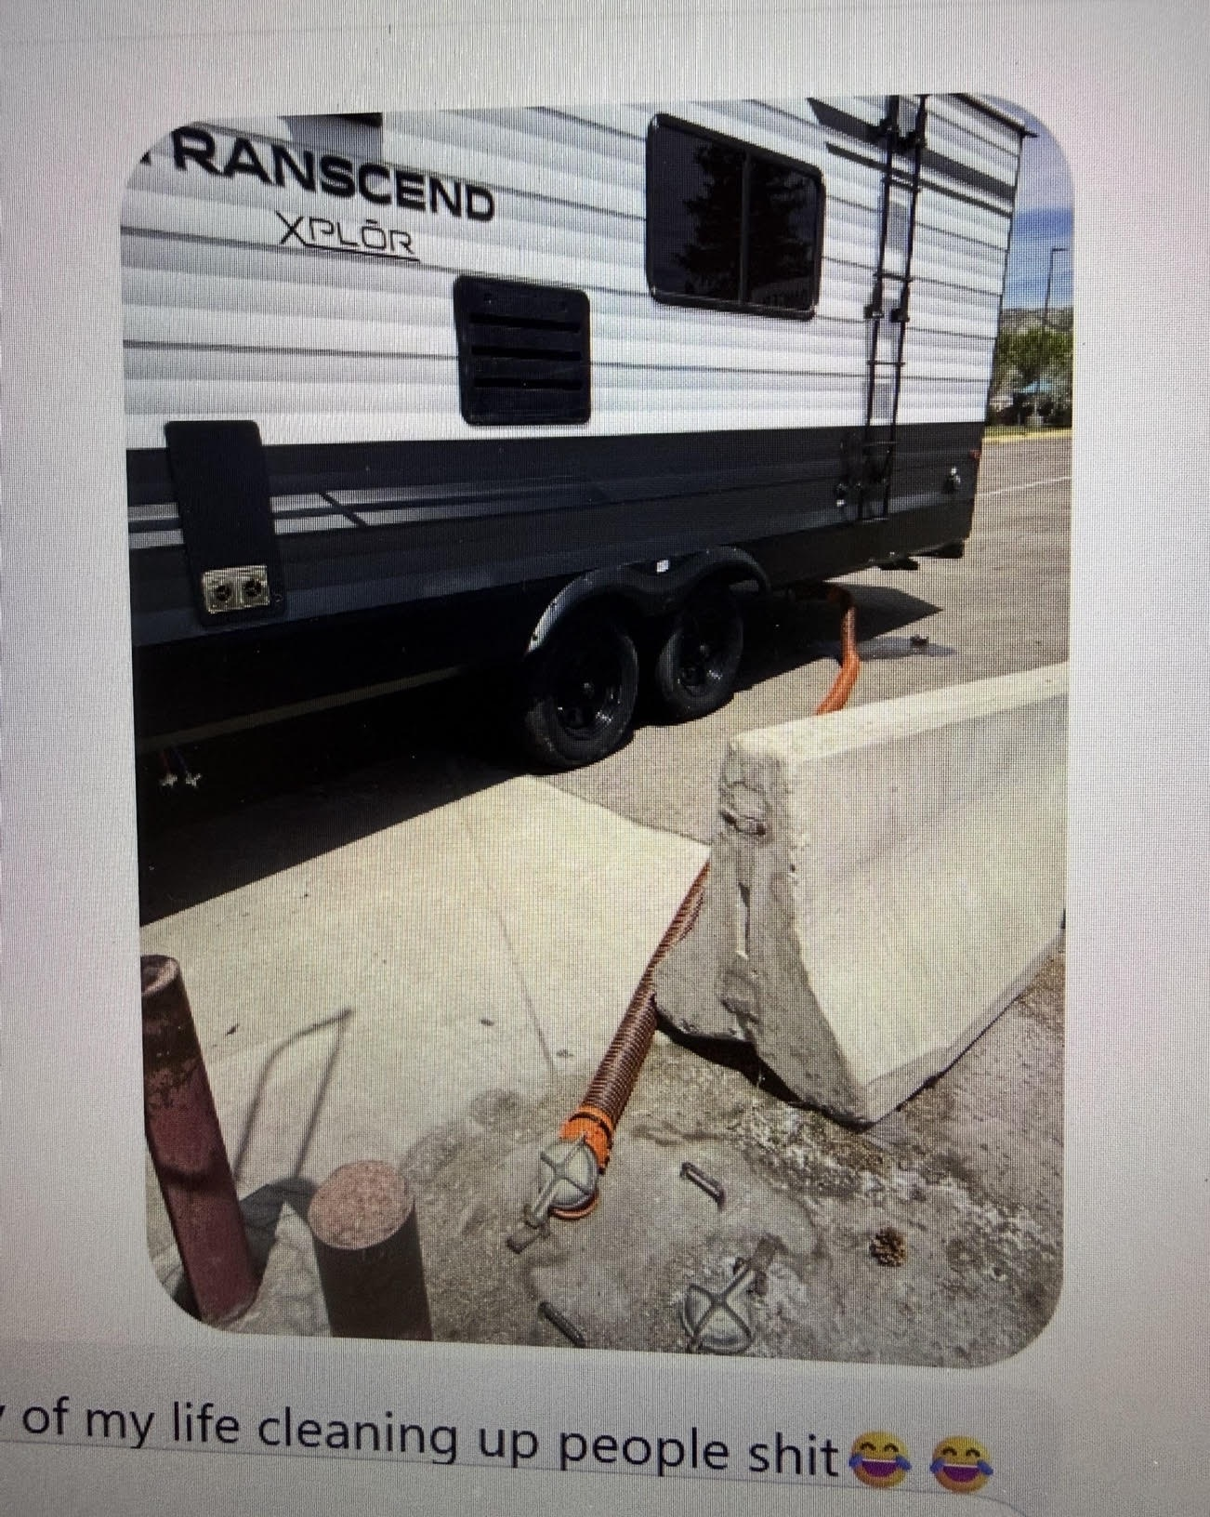
GLENDO, WYOMING

What if AI could clean up people’s stories?
Not rewrite them. Not change them. Simply organize scattered memories into something worth preserving.
I stood there for a moment realizing that maybe I wasn’t thinking about camper tanks anymore.
Maybe I was thinking about something much bigger.
· · ·
The first Spark had been lit.
I didn’t have a company.
I didn’t have a name.
I didn’t even know if it was possible.
I only had one question.
Can we create an app?
♥

Two
People Around the Fire
“A fire can be burning perfectly and still be waiting for someone to sit beside it.”
— Campy

Campfire worked.
I could open it on my phone, press Record, talk about something that happened in my life, and watch those words become a memory worth keeping.
It wasn’t perfect.
We had already crashed it once.
We had lost recordings.
We had spent nights testing things that should have worked and didn’t.
But the important part worked.
I could talk.
Campfire could listen.
And the memory stayed.
For a while, I thought that was the hard part.
It wasn’t.
· · ·
I showed Campfire to Brittany.
She had watched me working on it. She knew how much time I was spending talking to Fizzy, changing things, breaking things, fixing them and trying again.
When she finally saw what Campfire was becoming, she told me it was one of the most amazing things I had ever done.
That meant a lot coming from her.
She also thought I should be careful about showing it to too many people. We had something special. Maybe we should keep it quiet until it was ready.
Then she said something I didn’t expect.
She wouldn’t use it.
She loved Campfire.
She believed in what I was building.
She just didn’t see herself sitting down and pressing Record.
At first, I didn’t realize how important that was.
Later, I would understand that Brittany had shown me the next problem Campfire had to solve.
Someone could love the idea of preserving their life without actually doing it.
They could think Campfire was wonderful and still never tell Campfire a story.
· · ·
So I started inviting people to sit around the fire.
Not thousands of people.
People I knew.
Family.
Friends.
People whose opinions I trusted enough to hear when something didn’t work.
Some opened Campfire and started exploring.
Some recorded a memory.
Some recorded several.
Some looked around and left.
Some never came in at all.
And that was when Campfire stopped being just the app I was building.
It started becoming something I had to learn from.
The Journey Map would eventually give this problem a name:
The Admiration Gap.
Someone could say:
This is amazing.
And still never press Record.
That changed the question.
Can we build Campfire?
Now we were asking:
How do we help someone tell the first story?
· · ·
That question began changing Campfire.
We started thinking less about features and more about the moment before someone speaks.
What does a person see when they arrive?
Do they know what they’re supposed to do?
Does an empty Campfire feel inviting?
Or does it feel like an empty page?
Should we give them an idea?
Should we ask them a question?
Should Campfire wait quietly?
Should Campy help?
We had built a place that could preserve a story.
Now we had to make it feel safe and easy enough to begin one.
· · ·
And there was another thing I was beginning to understand.
People don’t organize their lives the way software organizes data.
They don’t think:
I would like to create record number forty-seven.
They think about people.
Mom.
Dad.
Brittany.
The kids.
The grandkids.
A friend they haven’t seen in years.
They think about places.
A campground.
A kitchen.
A school.
A beach.
A house they used to live in.
They think about parts of their lives.
Work.
Family.
Vacations.
Traditions.
Things that made them laugh.
Things they never want to forget.
Campfire needed to understand life that way too.
· · ·
On June 20, something appeared in Campfire that gave that idea a name.
People Around the Fire.
The name mattered.
These weren’t contacts.
They weren’t followers.
They weren’t friends in the social-media sense.
They were the people who belonged in your stories.
The people sitting around your fire.
That distinction would become more important than I understood at the time.
Because Campfire was never supposed to become another place where people performed their lives for everybody else.
It was supposed to help them keep their lives.
· · ·
And slowly, Campfire began learning how to do more than listen.
It learned how to remember who people were.
It learned how memories belonged together.
It learned how a story could be shared.
It learned how something one person remembered could matter to somebody else.
On June 21, published Storybooks appeared.
Storyteller profiles and welcome experiences followed on June 22.
Keepsakes appeared June 27.
Feedback arrived June 29.
Those dates are part of the history.
But sitting there building it, it didn’t feel like a list of features.
It felt like questions.
What would make this easier?
What would make this feel more human?
What would make somebody want to come back?
And underneath all of them was the same question Brittany had unknowingly handed me:
What gets someone to press Record?
· · ·
Campy was changing too.
In the beginning, Campy was an idea.
A little warmth inside the app.
A way for Campfire to feel less like software.
But the more real people began using Campfire, the more important that warmth became.
Campy couldn’t feel like a notification system.
He couldn’t nag someone because they hadn’t recorded today.
Campfire wasn’t going to have streaks.
It wasn’t going to make somebody feel guilty because life got busy.
Campy needed to feel like someone tending the fire.
There when you needed him.
Quiet when you didn’t.
· · ·
Something else happened as people began using Campfire.
I stopped being able to imagine it only through my own eyes.
That may have been one of the biggest changes of all.
When Campfire was just mine, I knew how everything worked because I had helped create everything.
A button didn’t need to explain itself to me.
An empty screen didn’t confuse me.
I knew what Campy meant.
I knew why Chapters existed.
I knew what I was supposed to say when I pressed Record.
Other people didn’t.
Every hesitation told us something.
Every person who couldn’t figure something out told us something.
Every person who recorded once and disappeared told us something.
And every person who came back and recorded another memory told us something too.
Real people were becoming part of the design.
· · ·
That changed the way Fizzy and I worked.
After the crash, we had already learned to be more careful.
Now we were learning to be more curious.
Instead of only asking:
Does this work?
We started asking:
Will someone understand it?
Will they know what to do next?
Does it feel like Campfire?
Are we helping them tell their story, or are we getting in the way?
The app was getting more complicated.
The idea was getting simpler.
Open. Talk. Done.
· · ·
I still wanted Campfire in the App Store.
That had been part of the dream almost from the beginning.
For a while, I thought the path was straightforward:
Build Campfire.
Get it working.
Put it in the App Store.
Launch it.
But Campfire was teaching me that “launch” might mean something different.
We didn’t need to wait for an app store to tell us whether the idea worked.
We could put Campfire into people’s hands now.
We could watch people use it.
We could learn.
We could make it better.
And someday, if Campfire did make its way to Apple, I didn’t want to arrive with an idea.
I wanted to arrive with a fire already burning.
· · ·
I had started Campfire because I wanted a better way to preserve my own life.
That was enough to light the first Spark.
But it wasn’t enough to build Campfire.
For that, other people had to sit down beside it.
They had to show us what confused them.
What moved them.
What they ignored.
What made them come back.
And sometimes what they never did at all.
Brittany still hadn’t pressed Record.
In a strange way, that made her one of Campfire’s most important early storytellers.
Without telling Campfire a story, she had taught it something it needed to know:
A memory can only be preserved after someone decides it’s worth telling.
We had learned how to keep the memory.
Now we had to earn the moment before it.
The fire was burning.
There were finally people sitting around it.
And Campfire was beginning to learn how to listen to more than just me.
♥

The Campfire Book · Second Edition
© 2026 Campfire Technologies LLC. All Rights Reserved.
Founded in Cheyenne, Wyoming.
Set in Fraunces and Instrument Sans. 7 × 10 inches, mirrored margins.
An internal publication. Not for distribution.

