♥
The Campfire Book
FIRST EDITION

Preserve What Matters.

♥
The Campfire Book
FIRST EDITION
Campfire Technologies LLC
Cheyenne, Wyoming



One
The Beginning
“Every story begins as a moment someone almost forgot.”
— Campy

I had started using AI as a personal journal.
Not for work. Not for anything clever. Every day I talked with it about my life — what happened, who I saw, what was weighing on me, what made me laugh. It was the easiest way I had ever found to say the day out loud.
Every week I saved those conversations. I saved them because I imagined that one day my children — and someday my grandchildren — might enjoy reading them. Not the polished version of me. The real one.
In the summer we took the camper to Glendo, Wyoming.
It was a good trip. On the way home I pulled into the dump station to empty the black and gray tanks before heading back, because that is what you do. Nobody takes a picture of that part of camping.
Standing there, doing the thing every camper eventually has to do, I laughed and texted:
“Story of my life… cleaning up people’s shit 😂😂”
And then, still standing there, a different thought arrived.

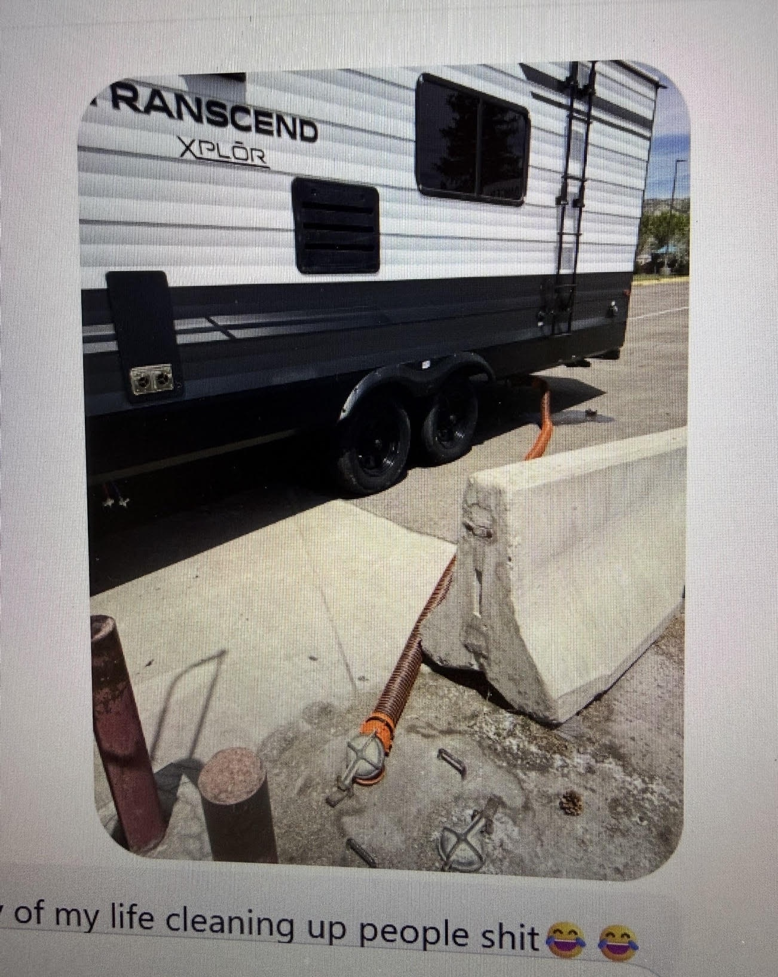
GLENDO, WYOMING

What if AI could clean up people’s stories?
Not rewrite them. Not change them. Simply organize scattered memories into something worth preserving.
I stood there for a moment realizing that maybe I wasn’t thinking about camper tanks anymore.
Maybe I was thinking about something much bigger.
· · ·
The first Spark had been lit.
I didn’t have a company.
I didn’t have a name.
I didn’t even know if it was possible.
I only had one question.
Can we create an app?
♥

The Campfire Book · First Edition
© 2026 Campfire Technologies LLC. All Rights Reserved.
Founded in Cheyenne, Wyoming.
Set in Fraunces and Instrument Sans. 7 × 10 inches, mirrored margins.
An internal publication. Not for distribution.

